Geopolitical Risk and Long-Term Stock Market Volatility: Evidence from the Korean Peninsula Using a GJR-GARCH-MIDAS Framework

Appendix A: Background
Since the 1950s, geopolitical risk (GPR) has been widely recognized as a non-economic exogenous shock that significantly influences financial market stability and asset pricing (Salisu et al., 2022). GPR encompasses broad political uncertainties, such as war, terrorist attacks, military threats, and tensions in international relations, which significantly disrupt investor behavior and market expectations (Jung et al., 2021). Unlike traditional macroeconomic variables (such as interest rates and inflation), GPR typically shocks the market in an unpredictable, sudden, and highly asymmetric manner, directly disrupting investor confidence and thereby increasing market volatility. In response, investors tend to exhibit heightened risk aversion, and through mechanisms such as adjustments in risk preferences and expectations, these short-term reactions gradually evolve into a broader reassessment of long-term risks (Salisu et al., 2023).
In recent years, a series of studies have emphasized the key role of GPR in asset volatility modeling. Related studies show that during periods of rising GPR, market uncertainty expectations increase, and volatility risk premiums rise significantly, thereby exacerbating asset price volatility (Zhang et al., 2023). Especially in open economies, GPR may accelerate risk transmission through cross-border capital flows and exhibit stronger systemic uncertainty characteristics (Balcilar et al., 2018). Additionally, different types of geopolitical events have heterogeneous effects on stock markets; for example, war risks may trigger more severe market reactions compared to diplomatic tensions (Ijaz et al., 2025).
As a highly open, medium-sized economy, South Korea's stock market is increasingly sensitive to global capital allocation. Although macroeconomic fundamentals remain an important driver of asset volatility, the long-standing security dilemma on the Korean Peninsula, such as nuclear tests (Huh & Pyun, 2018), missile launches (Lee, 2024), and border conflicts (Son & Moon, 2021), not only constitutes a structural geopolitical threat, but also exhibits three characteristics: cyclical escalation, sudden release, and persistent disturbance in multiple rounds of crisis events. This complex risk variable differs from the short-term event-driven GPR faced by other countries and has stronger characteristics of systemic uncertainty.
Although existing studies generally agree that GPR exacerbates short-term market volatility, there are still differences in the direction of its impact on long-term volatility. On the one hand, high-intensity geopolitical events, such as nuclear tests, are often considered to significantly increase investors' risk aversion, triggering risk-averse behavior and amplifying market reactions (Pyo, 2021). On the other hand, some recent studies have pointed out that in situations of repeated exposure to risk, investors may experience a “familiarity effect” or “risk desensitization” manifested as a gradual dullness in their response to geopolitical events and a gradual internalization of risk within the market, thereby suppressing the upward trend of long-term volatility (Kim & Roland, 2014). This is more pronounced in countries with mature policy response mechanisms and extensive market experience, where investors may adopt conservative strategies or adopt a wait-and-see attitude, leading to a stabilization of volatility levels.
Against this backdrop, there is an urgent need to conduct an in-depth assessment of the heterogeneous mechanisms of Geopolitical Risk from North Korea (GPRNK) at different time scales, especially their dynamic role in explaining and predicting long-term volatility in the South Korean stock market. This will not only help improve the theory of financial market responses to external shocks but also provide South Korean policymakers and investors with a more accurate basis for risk management.

Appendix B: Literature Review
In recent years, the impact of GPR on financial markets has become an important research topic in the field of international finance. With the intensification of global political uncertainty, the frequent turmoil on the Korean Peninsula has made South Korea's financial markets an important window for studying the effects of geopolitical shocks. A large body of literature shows that geopolitical events, especially North Korea's nuclear tests (Huh & Pyun, 2018), missile launches (Lee, 2024), and military provocations (Son & Moon, 2021), have a significant impact on South Korean asset markets mainly through short-term channels, manifested in exchange rate volatility (Dibooglu & Cevik, 2016), stock market declines (Lee, 2024), and rising bond risk premiums (Chernov et al., 2023).
Specifically, rising war risks not only suppress the overall returns of the South Korean stock market (NguyenHuu & Örsal, 2024) but also trigger differentiated responses across industries (Jung et al., 2021), exhibiting significant inter-sectoral heterogeneity. For example, firms closely linked to sectors such as defense and energy typically face stronger shocks (Naimy et al., 2025). Multiple geopolitical events (such as nuclear tests coupled with missile launches) can also trigger systemic market volatility, exacerbating stock market panic, pushing up credit spreads, and triggering depreciation pressure on the Korean won, indicating that the market is highly sensitive to “extreme geopolitical scenarios” (Ha et al., 2022).
To more effectively capture the immediate market response and risk perception, some studies have introduced the Search Volume Index (SVI) as a proxy for investor sentiment. Huh and Pyun (2018) found that in the early stages of geopolitical threats, the SVI rose significantly and was closely related to abnormal volatility in financial asset prices. However, as related events recurred, market sensitivity showed a downward trend, reflecting that investors may have developed risk “familiarity” or an “adaptation effect”. Similarly, Park and Park (2020) pointed out that the market's response to North Korean nuclear activities has gradually accelerated, particularly demonstrating a certain regulatory capacity in the foreign exchange market, indicating the existence of short-term adaptive mechanisms.
Beyond short-term shock studies, some literature has also begun to focus on the impact of policy communication and diplomatic expectations on the market. M. Al-Awadhi et al. (2025) found through an event study that major unexpected events on the Korean Peninsula often triggered short-term volatility in the South Korean stock market. In recent years, research on inter-Korean summit talks and peace negotiations has also become increasingly rich. Lee and Yoo (2020) found that the market exhibited significant cumulative abnormal returns (CAR) in response to information related to the peace process. Companies involved in inter-Korean economic cooperation typically received positive excess returns, while defense-related companies exhibited negative expectations. This suggests that the market not only responds quickly to geopolitical information but also makes structural judgments based on its nature and direction.
Overall, the existing literature has systematically revealed the short-term impact of geopolitical events on South Korea's financial markets, emphasizing abnormal volatility in asset prices both before and after these events. However, research on the long-term dimension remains clearly insufficient, particularly in explaining how GPRs are gradually transmitted and internalized into market volatility through intermediary variables such as investor risk expectations, international capital flow paths, and market restructuring mechanisms. GPR, as an exogenous, non-economic shock variable, can significantly enhance the predictive accuracy of volatility models in high-volatility environments, supplementing the explanatory power of traditional macroeconomic indicators (Foglia et al., 2025; Li & Liu, 2025). This provides a more robust theoretical foundation and behavioral mechanism explanation for the present study.
Based on this, this study takes GPRNK as the core variable. It systematically examines its dynamic impact on the long-term volatility of the South Korean stock market. By introducing a heteroskedastic volatility modeling framework (GJR-GARCH-MIDAS model), this study aims to fill the gaps in existing research on long-term volatility modeling, the identification of cross-spatial and temporal risk transmission mechanisms, and multi-scale risk prediction, thereby providing theoretical support and empirical evidence for financial regulators and investors to formulate more forward-looking and targeted risk management policies in a highly geopolitically uncertain environment.

Appendix C: Data Sources
The KOSPI index data used in this study comes from the Korean FnGuide data website. Due to data availability, the sample period selected for the study is from 4 January 2000 to 30 September 2021. To calculate the stock market's daily return, we multiply the logarithmic return by 100, denoted as R, and then calculate the monthly RV using the sum of the squares of the daily returns. Figure A1 illustrates the evolution of the time-series dynamics of the log daily returns of the KOSPI index and its corresponding monthly realized volatility, based on these returns, revealing the characteristics and trends of stock market volatility over the sample period.
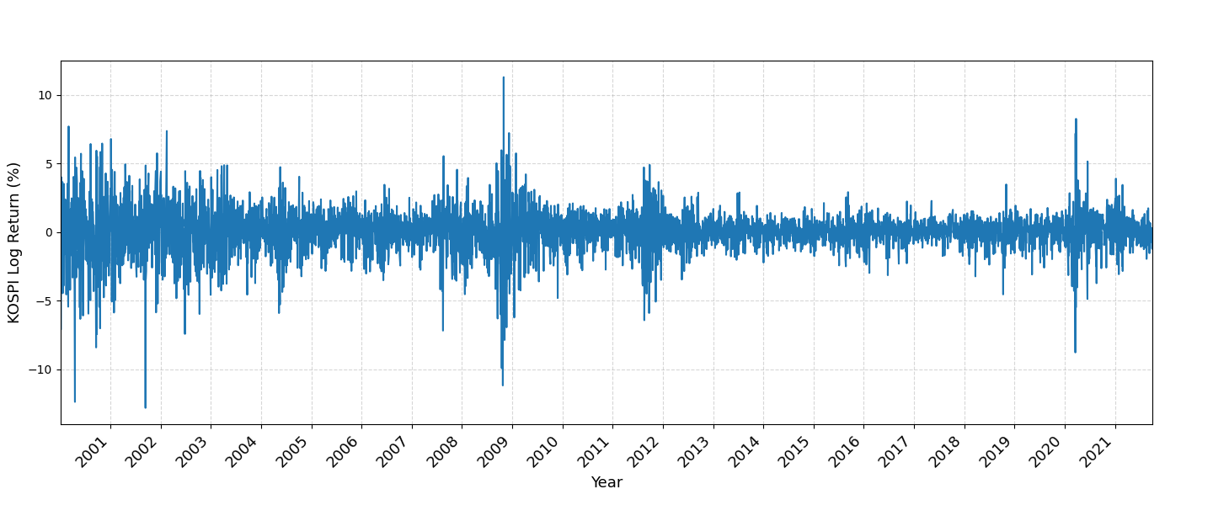
Logarithmic daily rate of return
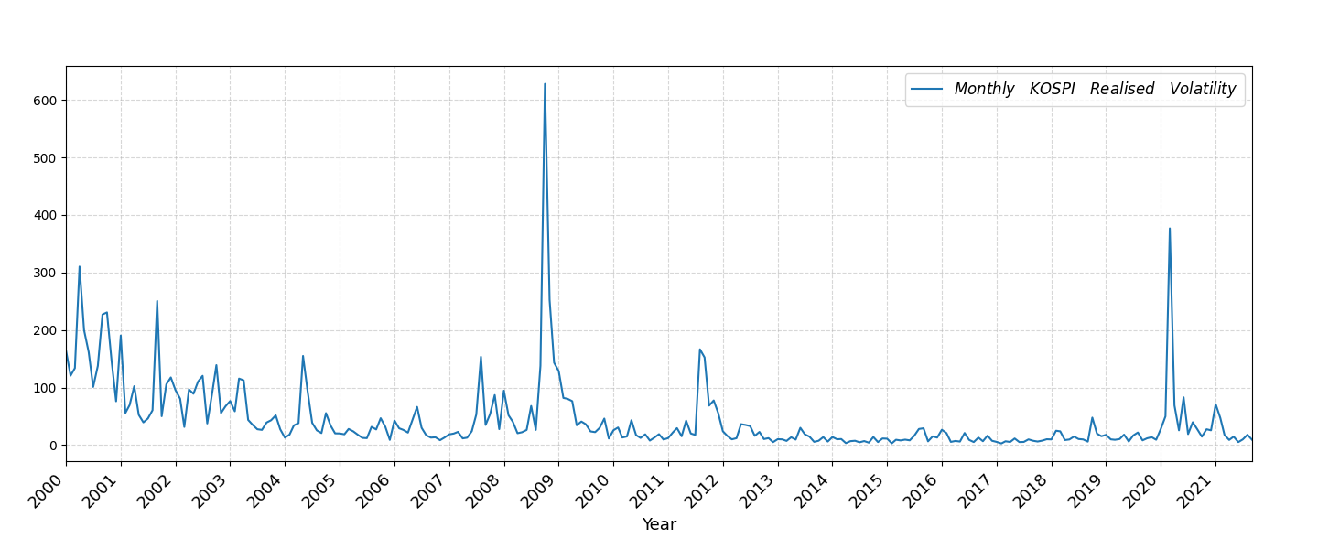
Realised volatility
Figure A1. Time Series Dynamics of Log Daily Returns and Monthly Realised Volatility of KOSPI Indexes
In addition, the GPRNK data used in this study originate from Jung et al. (2021), which were constructed from news articles provided by BigKinds, a news analysis platform operated by the Korea Press Foundation. The index data are publicly available on the Economic Policy Uncertainty Index website. To illustrate the rate of change in GPRNK, the original data undergoes logarithmic differencing followed by multiplication by 100 to yield the GPRNK change rate (ΔGPRNK), which characterizes the dynamic fluctuations of GPRNK. Figure A2 illustrates the time-series trend of GPRNK throughout the study, highlighting its volatility characteristics.
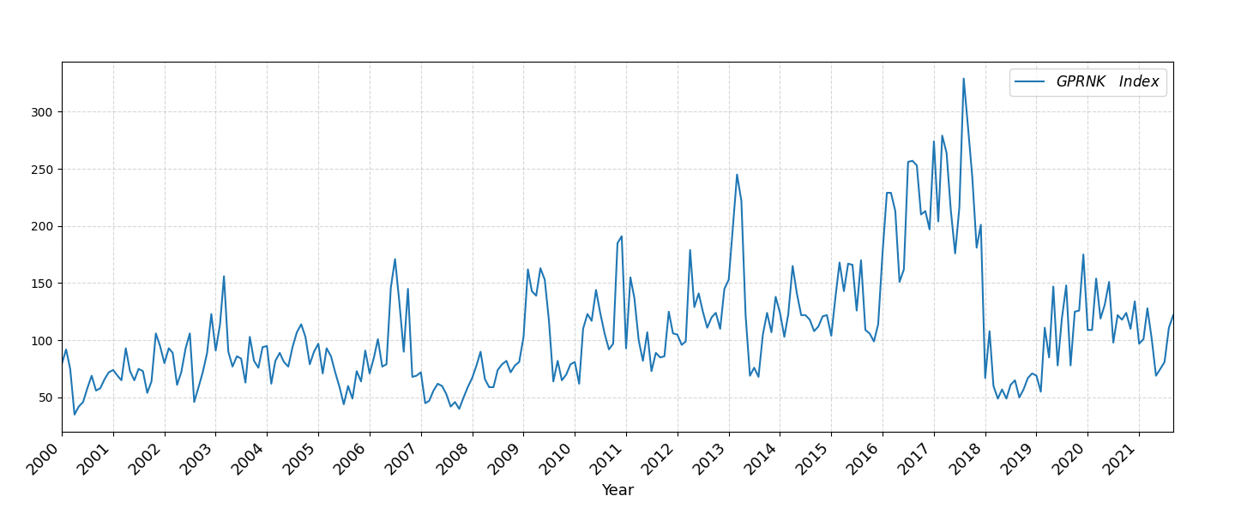
GPRNK Index
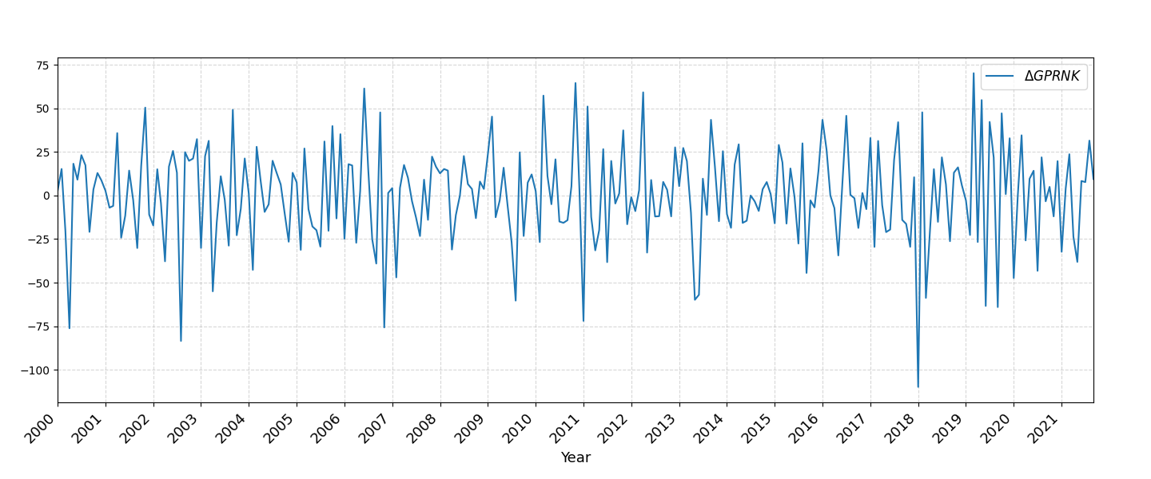
$$ΔGPRNK$$
Figure A2. GPRNK time series and its rate of change
The descriptive statistical results are shown in Table A1. The analysis reveals that all variables exhibit significant deviations from a normal distribution. The mean value of the return rate (R) is close to zero; the distribution is left-skewed (skewness of -0.558), and it has the characteristics of a thick-tailed spike (kurtosis of 7.071). The Jarque-Bera test significantly rejects the hypothesis of a normal distribution, indicating typical characteristics of financial time series. The realized volatility (RV) has a high mean value, a right-skewed distribution (skewness of 4.331), and a kurtosis of 28.290, which indicates significantly high volatility and extreme value characteristics. The mean of the North Korea political risk change rate (ΔGPRNK) is low, with a skewness of -0.470 and a kurtosis of 0.986, indicating a distribution close to the normal distribution level. However, the Jarque-Bera test still rejects the normality hypothesis. In addition, all series passed the ADF stationarity test, indicating that the data do not contain unit roots and are suitable for further econometric analysis.
Table A1. Descriptive statistics
 | Mean | Std.dev | Max | Min | skewness | kurtosis | J-B | ADF
R | 0.020 | 1.479 | 11.284 | -12.805 | -0.558 | 7.071 | 11463.999*** | -34.082***
RV | 44.993 | 64.509 | 627.862 | 2.906 | 4.331 | 28.290 | 9519.721*** | -5.268***
$$ΔGPRNK$$ | 0.176 | 27.603 | 70.220 | -109.861 | -0.470 | 0.986 | 20.159*** | -14.744***
Note: J-B stands for Jarque-Bera test for normal distribution, whose original hypothesis is that the series obeys normal distribution; ADF stands for Augmented Dickey-Fuller unit root test, whose null hypothesis is that the series contains a unit root, i.e., is non-stationary. ***,**,* denote the rejection of the original hypothesis at the 1%, 5% and 10% significance levels, respectively.

Appendix D: In-Sample Prediction Test
This study constructs a stock market volatility model suitable for GPR analysis based on the GARCH-MIDAS framework proposed by Engle et al. (2013). By decomposing the volatility of stock market returns into short-term and long-term components, this model can systematically examine the impact of GPR on the stock market's long-term volatility.

Fixed Window Model
Considering the return on the KOSPI index, the model is set up as follows:
$$\begin{aligned}r_{i,t}=μ+\sqrt{τ_{t}*g_{i,t}}ε_{i,t} ∀i=1,…,N_{t}\#\left(A1\right)\end{aligned}$$
Where $r_{i,t}$ denotes the log return of the KOSPI index and t is the time-frequency (in months); $μ$ is the conditional expectation; $τ_{t}$ denotes the long-term volatility component and $g_{i,t}$ denotes the short-term volatility component; and $ε_{i,t}$ is a standard normal white noise series that satisfies $ϵ_{i,t}|ϕ_{i-1,t}\sim N(0,1)$ . In addition, the logarithmic rate of return is calculated as:
$$\begin{aligned}r_{i,t}=\ln\left(\frac{P_{i,t}}{P_{i-1,t}}\right)*100\#(A2)\end{aligned}$$
Where $P_{i,t}$ and $P_{i-1,t}$ are the stock market closing prices on day i and i-1 of month t, respectively.

Modelling short-term volatility
The modeling approach for short-term volatility $g_{i,t}$ refers to the research of Conrad and Kleen (2020), adopts the GJR-GARCH(1,1) model definition, which is expressed as follows:
$$\begin{aligned}g_{i,t}=\left(1-α-\frac{γ}{2}-β\right)+\left(α+γ*I_{\left\{ε_{i-1,t}<0\right\}}\right)\frac{ε_{i-1,t}^{2}}{τ_{t}}+βg_{i-1,t}\#\left(A3\right)\end{aligned}$$
Where $I_{\left\{ε_{i-1,t}<0\right\}}$ is the indicator function, which takes the value of 1 when $ε_{i-1,t}<0$, otherwise it is 0. The model parameters need to meet $α>0; β≥0$, and $α+β +\frac{γ}{2}<1$ to ensure the stability of the model. The parameter $γ$ is used to measure the asymmetric effect of volatility. When $γ>0$ and significant, it indicates that the negative shocks have a greater impact on volatility than positive shocks. There is no linear asymmetric effect if $γ>0$, which is insignificant.
Long-term volatility $τ_{t}$ can be expressed through the realized volatility (${RV}_{t}$) or the GPR index (GPRNK). Considering that exogenous variables may positively or negatively impact volatility, this study uses logarithmically treated variables to ensure that the value of $τ_{t}$ is always positive. It is expressed as follows:
$$\begin{aligned}lnτ_{t}=m+θ\sum_{k=1}^{K}{φ_{k}\left(w_{1},w_{2}\right)X_{t-k}}\#\left(A4\right)\end{aligned}$$
Among them, $m$ is the constant term, $K$ is the maximum lag order of the realized volatility ${RV}_{t}$, $θ$ is the long-term impact coefficient, and $X_{t-k}$ is the lag value of the exogenous variable (such as the GPR index). ${RV}_{t}$ is calculated as follows:
$$\begin{aligned}{RV}_{t}=\sum_{i=1}^{N_{t}}{r_{i,t}^{2}}\#\left(A5\right)\end{aligned}$$
Here, $r_{i,t}$ is the stock market return for each period, and $N_{t}$ is the total sample size over the period.
In the weight function, $w_{1}$ = 1 is set to ensure that the impact of each exogenous variable on long-term volatility shows a monotonically decreasing trend. In this way, the weight function can be simplified as follows:
$$\begin{aligned}φ_{k}\left(w_{2}\right)=\frac{{\left(1-\frac{k}{K}\right)}^{w_{2}-1}}{\sum_{j=1}^{K}{{\left(1-\frac{j}{K}\right)}^{w_{2}-1}}}\#\left(A6\right)\end{aligned}$$
According to Engle et al. (2013), for variables with daily and monthly frequencies, selecting K = 36 as the lag order can significantly improve the model's predictive power. Therefore, in this study, the lag order is set to K = 36 to ensure that the model can capture the dynamic characteristics of long-term volatility more effectively.
Through Equations (A1), (A3), (A4), and (A6), a fixed-window version of the univariate GJR-GARCH-MIDAS model is constructed. This model can stably process both short-term and long-term volatility components, providing a theoretical framework and empirical basis for analyzing the impact of GPR on stock market volatility.

Rolling Window Model
Meanwhile, to further improve the model's flexibility, this study also considers a rolling window prediction version of the univariate model (Dai et al., 2022). In this version, the model for short-term volatility remains unchanged. In contrast, the realized volatility ${RV}_{t}$ is dynamically adjusted by a rolling window. The rolling window version can adjust the model in real time according to the latest changes in the market, thereby enhancing its adaptability and forecasting ability. Specifically, the realized volatility ${RV}_{t}$ calculation formula is modified as follows:
$$\begin{aligned}{RV}_{t}^{\left(rw\right)}=\sum_{j=1}^{N^{'}}{r_{i-j,}^{2}}\#\left(A7\right)\end{aligned}$$
$r_{i-j}$ is the backward rolling daily return, and $N^{'}$is the number of monthly trading days, and for simplicity of calculation, we set it to $N^{'}=22$ in the model.
Then the formula for GPRNK is:
$$\begin{aligned}X_{i}^{\left(rw\right)}=\frac{1}{N^{'}}\sum_{j=1}^{N^{'}}{X_{i-j,}}\#\left(A8\right)\end{aligned}$$
Where $X_{i}$ is a daily variable whose value is equal to the corresponding monthly value; $X_{i}^{\left(rw\right)}$ is the average value of a month before $i$ day. The corresponding long-run volatility $τ_{t}$ can be rewritten as:
$$\begin{aligned}lnτ_{t}^{\left(rw\right)}=m^{\left(rw\right)}+θ^{\left(rw\right)}\sum_{k=1}^{K}{φ_{k}\left(w_{1},w_{2}\right)X_{t-k}^{\left(rw\right)}}\#\left(A9\right)\end{aligned}$$
Therefore, Equations (A1), (A3), (A6), and (A9) constitute the rolling window version of the univariate GJR-GARCH-MIDAS model.
Based on the univariate GJR-GARCH-MIDAS model, this study further constructs a bivariate GJR-GARCH-MIDAS model. This model introduces two exogenous variables, realized volatility(${RV}_{t}$) and GPR index (GPRNK), to comprehensively capture the changes in long-term volatility. The long-term volatility component of the bivariate GJR-GARCH-MIDAS model is expressed as follows:
$$\begin{aligned}lnτ_{t}=m+θ_{1}\sum_{k=1}^{K}{{φ_{1}}_{k}\left(w_{1,1},w_{1,2}\right){RV}_{t}}+θ_{2}\sum_{k=1}^{K}{{φ_{2}}_{k}\left(w_{2,1},w_{2,2}\right)X_{1,t-k}}\#\left(A10\right)\end{aligned}$$
For the rolling window version, the expression for long-term volatility $τ_{t}^{\left(rw\right)}$ is:
$$\begin{aligned}lnτ_{t}^{\left(rw\right)}=m^{\left(rw\right)}+θ_{1}^{\left(rw\right)}\sum_{k=1}^{K}{{φ_{1}}_{k}\left(w_{1,1},w_{1,2}\right){RV}_{t}^{\left(rw\right)}}+θ_{2}^{\left(rw\right)}\sum_{k=1}^{K}{{φ_{2}}_{k}\left(w_{2,1},w_{2,2}\right)X_{1,t-k}^{\left(rw\right)}}\#\left(A11\right)\end{aligned}$$
In summary, Equations (A1), (A3), (A6), and (A10) are the fixed-window versions of the two-factor GJR-GARCH-MIDAS model. Equations (A1), (A3), (A6), and (A11) are the rolling-window versions of the two-factor GJR-GARCH-MIDAS model. The GARCH-MIDAS model proposed in this study can more accurately capture the dynamic characteristics of stock market volatility by combining short-term and long-term volatility modeling methods. While the fixed-window version is suitable for static analysis, the rolling-window version can respond more flexibly to rapid changes in the market environment. The introduction of the two-factor model further improves the model's ability to explain long-term volatility, providing theoretical support and an empirical basis for studying the impact of GPR on stock market volatility.

Appendix E: Out-of-Sample Prediction Test

Model Confidence Set (MCS) Test
To systematically evaluate the model's predictive performance outside the sample, this study adopts the Model Confidence Set (MCS) test method proposed by Hansen et al. (2011). This method quantifies the model's prediction error by introducing an appropriate loss function to compare the prediction performance of different models. Given that Diebold and Lopez (1996) pointed out that the selection of the most appropriate loss function to measure the accuracy of predicting volatility is a complex and difficult problem to unify standards, this study finally selected three common loss functions for comparison and evaluation: mean squared error (MSE), mean absolute error (MAE), and quasi-likelihood error (QLIKE). The specific formulas are as follows:
$$\begin{aligned}MSE=\frac{1}{n}\sum_{n=1}^{N}{{\left(σ_{t}^{2}-{\hat{σ}}_{t}^{2}\right)}^{2}}\#\left(A12\right)\end{aligned}$$
$$\begin{aligned}MAE=\frac{1}{n}\sum_{n=1}^{N}{\left|σ_{t}^{2}-{\hat{σ}}_{t}^{2}\right|}\#\left(A13\right)\end{aligned}$$
$$\begin{aligned}QLIKE=\frac{1}{n}\sum_{n=1}^{N}{(ln\left({\hat{σ}}_{t}^{2}\right)+\frac{σ_{t}^{2}}{{\hat{σ}}_{t}^{2}})}\#\left(A14\right)\end{aligned}$$
Where $σ_{t}^{2}$ is the square of the stock market return, which serves as a proxy for volatility, and $σ_{t}^{2}$ is the forecasted volatility that the model estimates. By comparing these three loss functions, we can comprehensively evaluate the model's forecast error and select the optimal model based on its performance.
For the MCS test, this research included the GJR-GARCH (1,1) model and the GJR-GARCH-MIDAS model for each variable in the model confidence set ($M$). To test whether there is a significant difference in the predictive performance of different models, we used two statistics: the maximum t-value ($T_{max,M}$) and the range statistic ($T_{R,M}$). The specific formulas are as follows:
$$\begin{aligned}T_{max,M}=max×\frac{{\overline{d}}_{a}}{\sqrt{\hat{var}\left({\overline{d}}_{a}\right)}}\#\left(A15\right)\end{aligned}$$
$$\begin{aligned}T_{R,M}=max×\left|\frac{{\overline{d}}_{a,b}}{\sqrt{\hat{var}\left({\overline{d}}_{a,b}\right)}}\right|, a,b∈M \#\left(A16\right)\end{aligned}$$
Among them, ${\overline{d}}_{a}$ is the average loss, ${\overline{d}}_{a,b}$ is the loss difference between $a$ and $b$ in the $M$ set, and $\hat{var}({\overline{d}}_{a})$ and $\hat{var}({\overline{d}}_{a,b})$ are the estimated variances of ${\overline{d}}_{a}$ and ${\overline{d}}_{a,b}$, respectively, which are obtained by estimating the static bootstrap method. Suppose the calculated statistic exceeds the pre-set critical value. In that case, the null hypothesis is rejected, indicating a significant difference in the prediction performance of different models on out-of-sample data.
This study refers to the research conclusions of Liu et al. (2018) and Wang et al. (2020). It adopts a p-value of 0.10 for the MCS confidence set to improve the efficiency and robustness of model selection. This p-value is determined by a bootstrap method 10,000 times, which can ensure the scientific nature and statistical significance of model selection.

Diebold and Mariano (DM) Test
To further compare the prediction accuracy of the two models, this study uses the method proposed by Diebold and Mariano (2002) for testing. The null hypothesis of the DM test is that there is no significant difference in the prediction ability of the two prediction models; their prediction accuracy is the same. The method quantifies the difference in prediction accuracy by calculating the difference in the prediction errors of the two models. Suppose the p-value of the difference is less than the pre-set significance level. In that case, the null hypothesis is rejected, indicating a significant difference in the prediction accuracy of the two models. The test provides quantitative evidence to help assess which model has higher prediction accuracy. The specific calculation formula is as follows:
$$\begin{aligned}DM=\frac{\overline{d}}{\sqrt{var\left(d_{s}\right)}}\sim N\left(0,1\right)\#\left(A17\right)\end{aligned}$$
$$\begin{aligned}D_{s}=E_{a,s}^{2}-E_{b,s}^{2}\#\left(A18\right)\end{aligned}$$
Where $E_{a,s}$ and $E_{b,s}$ represent the prediction errors of the two prediction models a and b at time point s, respectively, $\overline{d}$ is the mean of the difference sequence $d_{s}$, and $var(d_{s})$ is the variance of this difference sequence.

Appendix F: Lagged Weights and Model Estimation
The optimal lagged weights of the GJR-GARCH-MIDAS model, based on the fixed-span realized volatility (RV) and the rate of change of GPRNK ($ΔGPRNK$), estimated over the full sample period, can be visually observed from the weights distribution graph (Figure A3). The model introduces a 36-period lagged monthly RV and ΔGPRNK in the MIDAS regression to portray their long-term impact on stock market volatility. The graph's horizontal axis indicates the lag period (in months). Since the model is estimated using monthly fixed-span RV and ΔGPRNK, its weight distribution is characterized by a step function.
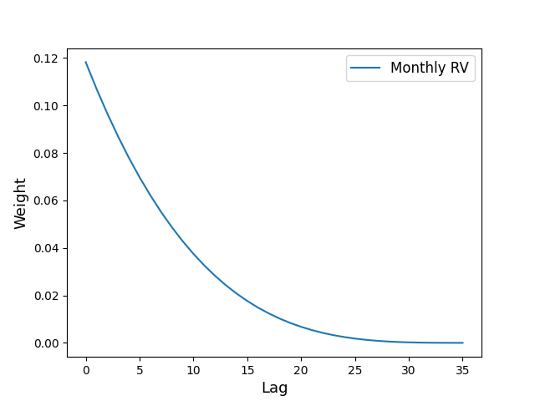 | 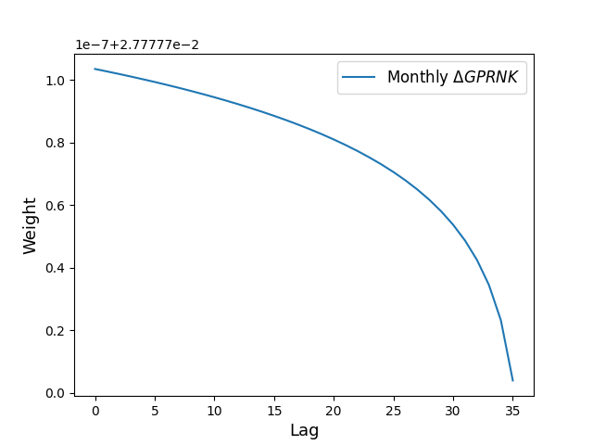
RV | $$ΔGPRNK$$
Figure A3. Weighting diagram
This result reveals the impact of RV and ΔGPRNK on stock market volatility and their lagged effects. The strength of the effect can be calculated from the estimated values of the $θ$ coefficient and the Beta weight function: a 1% increase in the realized volatility rate is associated with an increase of about 0.171% ($e^{0.016×0.107}-1≈0.171\%$) in stock market volatility in the next period. In comparison, a 1% increase in the ΔGPRNK rate is associated with a decrease of about 0.210% ($e^{-0.075×0.028}-1≈-0.210\%$) in stock market volatility in the next period. This result shows that changes in realized volatility in the short term can significantly increase market volatility. Rising GPR can suppress market volatility by prompting investors to adjust their asset allocation (e.g., increasing their safe-haven asset holdings). In addition, regarding lagged effects, as the lag order increases, the weight gradually decreases and tends to zero after 36 months, indicating that the two variables have a significant and sustained impact on stock market volatility over the next three years.
This result reveals the joint driving effect of short-term and long-term factors on stock market volatility, indicating that the Korean stock market can effectively absorb short-term shocks in the face of GPR and gradually adapt to external risks over a more extended period. This adaptability suggests that RV and ΔGPRNK not only have a significant impact on stock market volatility in the current period but also have a substantial driving effect on medium- and long-term volatility due to their lagged effects. Therefore, this finding provides a valuable reference for studying financial market volatility and policy formulation.
Judging from the models' LLH, AIC, and BIC values, the rolling window version shows a better fitting effect than the fixed window version. Specifically, the rolling window model usually has lower values for these goodness-of-fit indicators, indicating that it is more accurate in capturing data characteristics and adapting to market changes. This result shows that the rolling window method can better respond to changes in market volatility by dynamically adjusting the sample period, thereby improving the predictive power and adaptability of the model.
In addition, this conclusion can be further verified from the volatility chart (Figure A4). The figure clearly shows that the rolling window version of the model can more sensitively reflect stock market volatility, especially in the face of severe market volatility, and the volatility trajectory is closer to the actual data. This demonstrates that the rolling window model can capture market dynamics in real-time by continuously updating sample data, thereby avoiding the risk of overlooking market changes associated with a fixed window model that uses a fixed sample period. Therefore, the rolling window model is more applicable and advantageous when dealing with highly volatile and uncertain data, such as financial markets.
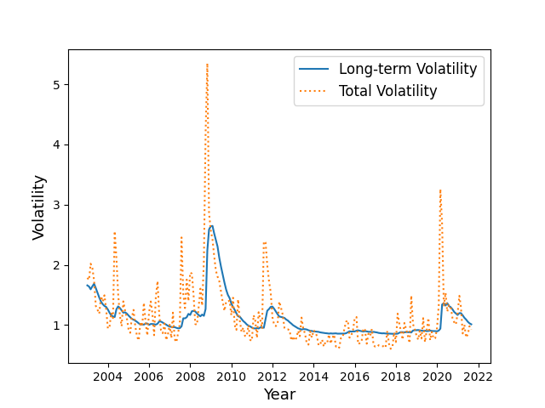 | 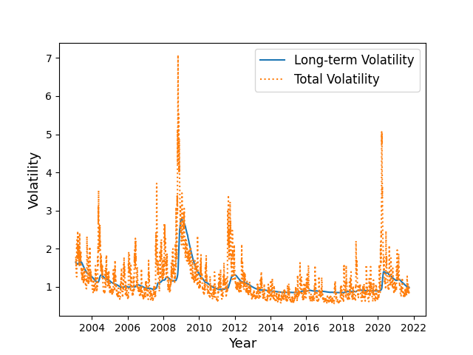
RV-Fixed window | RV- Rolling window
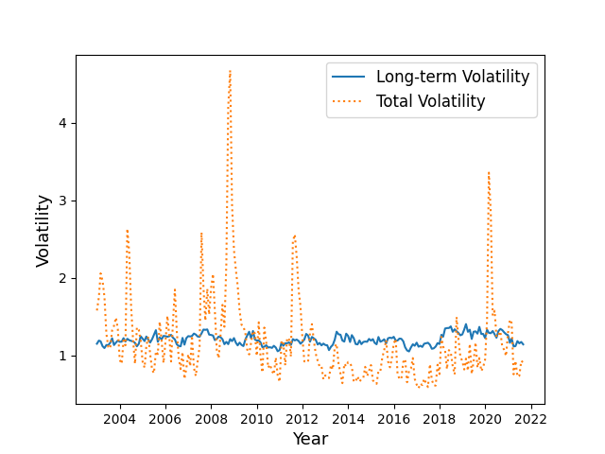 | 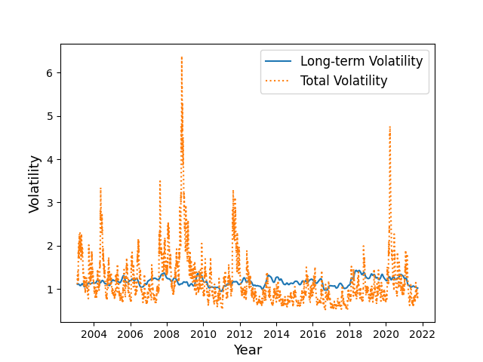
$ΔGPRNK$-Fixed window | $ΔGPRNK$-Rolling window
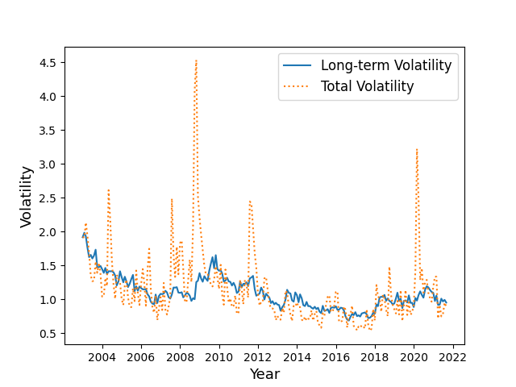 | 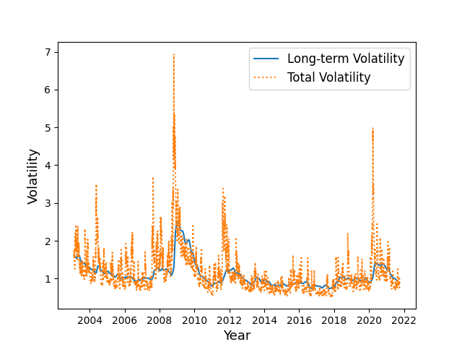
$RV+ΔGPRNK$-Fixed window | $RV+ΔGPRNK$-Rolling window
Figure A4. Relationship between long-term volatility (${lnτ}_{t}$) and total volatility ($τ_{t}*g_{i,t}$) estimated by each model

Appendix G: Robustness Checks
To further test the robustness of the model, this study shortens the out-of-sample prediction window to approximately three years (678 trading days). It continues to use the rolling prediction method to ensure the comparability and consistency of the results. This setting is used to evaluate the model's performance over a shorter prediction period and verify its robustness.
The results in Table A2 show that Model 2 (which only includes RV) and Model 6 (which incorporates both RV and GPRNK) perform excellently under various loss functions (MSE, MAE, QLIKE) and pass the MCS test, indicating that their predictive capabilities remain significant and robust even with a relatively short sample period. In particular, Model 6 performed the best overall, suggesting that combining realized volatility with GPR indicators enhances the accuracy of long-term volatility forecasts.
Table A2. MCS Test Results
 | MSE |  | MAE |  | QLIKE
MCS-678 days | $$T_{R}$$ | $$T_{max}$$ | $$T_{R}$$ | $$T_{max}$$ | $$T_{R}$$ | $$T_{max}$$
GJR-GARCH(1,1) | 0.283 | 0.112 | 0.090 | 0.066 | 0.060 | 0.827
Model 2 | 0.579 | 0.579 | 0.206 | 0.206 | 0.746 | 0.827
Model 4 | 0.283 | 0.119 | 0.089 | 0.046 | 1.000 | 1.000
Model 6 | 1.000 | 1.000 | 1.000 | 1.000 | 0.746 | 0.827
Note: The numbers in the table are p-values. Numbers greater than 0.10 are in bold and underlined, indicating that the corresponding model performs significantly better in the model set. The time horizon is 678 days.
Furthermore, the DM test results in Table A3 support the above conclusions. Under the MSE loss function, the prediction error of Model 6 decreased by approximately 5.6% compared to the baseline GJR-GARCH(1,1) model, and by approximately 4.8% under the MAE standard, demonstrating the important role of GPRNK in enhancing long-term volatility modeling. Although Model 4 (containing only RV) performs best under the QLIKE metric, Model 6 still outperforms the other models overall, further validating the effectiveness and robustness of jointly modeling high-frequency market information with GPR factors.
Table A3. DM test results
DM-678 days | MSE | MAE | QLIKE
Model 2 | 0.950***  (-3.605) | 0.960***  (-5.247) | 1.003  (0.054)
Model 4 | 0.993  (-1.414) | 0.993**  (-2.193) | 0.966***  (-2.791)
Model 6 | 0.944***  (-3.535) | 0.952***  (-4.726) | 1.007  (0.131)
Note: This table shows the results of the Diebold-Mariano forecast evaluation relative to various models for which the GJR-GARCH(1,1) model is used as a benchmark. A ratio of less than 1 indicates that the model predicts volatility better than the benchmark model.DM test statistics are shown in parentheses. The time horizon is 678 days. ***,**,* denote rejection of the original hypothesis at the 1 per cent, 5 per cent and 10 per cent significance levels, respectively.
In summary, Model 6 performed well overall under the three main evaluation indicators of MSE, MAE, and QLIKE, validating the high predictive ability of the combination of “realized volatility + GPRNK”. This model significantly improves the accuracy and robustness of long-term volatility prediction, providing a solid theoretical basis and empirical support for stock market volatility modeling.

Appendix H: Conclusions and Implications

Conclusions
Based on the GJR-GARCH-MIDAS model, this study empirically examines the impact of GPRNK on the long-term volatility of the Korean KOSPI stock market. The key findings are as follows: First, realized volatility exerts a significant positive effect on long-term volatility, indicating that short-term volatility has a cumulative impact on long-term market risk. Second, GPRNK exhibits a significant negative effect on long-term volatility, suggesting that heightened geopolitical tensions may prompt conservative or wait-and-see behavior among investors, thereby mitigating long-term volatility through market adaptation. Third, incorporating both realized volatility and GPRNK significantly enhances the model’s predictive performance, reducing forecast error by approximately 4.2%. This underscores the value of integrating high-frequency market dynamics with low-frequency geopolitical indicators in modeling long-term stock market volatility.

Discussion
This study finds that GPRNK exerts a significant negative impact on the long-term volatility of the South Korean stock market. This result aligns with existing theoretical and empirical research on the transmission of exogenous risks to financial market behavior. First, from a behavioral finance perspective, the phenomenon of volatility gradually diminishing over time is consistent with the concepts of habit formation and adaptive expectations (Bordalo et al., 2020). Amid persistent geopolitical tensions, investors recalibrate their risk perceptions, forming “risk-adaptive expectations” that reduce sensitivity to recurring shocks (Kim & Roland, 2014). This mechanism also aligns with prospect theory predictions: repeated exposure to losses alters reference points and mitigates the adverse effects of diminishing marginal utility (Kahneman & Tversky, 1979).
Second, the information accumulation and volatility transmission theory suggests that high-frequency shocks influence long-term volatility through temporal aggregation effects (Corsi, 2009). Thus, realized volatility becomes a key proxy for measuring the arrival and persistence of information. Our results demonstrate that incorporating GPRNK, an exogenous non-economic risk factor, significantly enhances the predictive power of long-term volatility in high-volatility environments, complementing the explanatory power of traditional macroeconomic indicators (Salisu et al., 2022).
Furthermore, the investor reaction heterogeneity framework emphasizes that investor responses to GPR vary depending on event characteristics, market structures, and behavioral biases (such as overreaction, herd behavior, and attention constraints) (BEKAERT et al., 2014). This heterogeneity provides micro-level evidence explaining why GPRNK may amplify volatility in the short term but dampen it in the long term.
In summary, multiple theoretical perspectives collectively reinforce this study's empirical finding that GPRNK exerts an adverse effect on long-term volatility. They also point to promising directions for future research, such as integrating more granular GPR indicators with investor-level behavioral data to identify underlying mechanisms and marginal effects.

Implications
The findings of this study carry significant practical implications for policymakers, regulatory authorities, risk managers, international investors, and other market participants.
For policymakers, it is essential to closely monitor geopolitical developments on the Korean Peninsula and establish proactive, flexible contingency mechanisms to mitigate the impact of sudden events on financial markets. During periods of heightened GPR, fiscal and monetary policy tools can be employed strategically to stabilize market expectations and reduce investor panic, thereby maintaining market stability.
Regulatory authorities should further strengthen risk disclosure requirements, enhance transparency, and promote cross-border regulatory cooperation to bolster market resilience. Risk managers need to systematically integrate GPR into their assessment frameworks, refine stress-testing models, and implement more effective hedging strategies.
For international investors, the geopolitical sensitivity of the Korean market highlights the importance of risk diversification and defensive investment strategies in cross-border portfolio allocation, along with dynamic adjustments that align with long-term investment objectives. Individual investors should likewise incorporate geopolitical factors into asset allocation and long-term risk management, adjusting portfolio structures and enhancing hedging measures to achieve a more optimal balance between risk and return.
Ultimately, establishing a coordinated risk governance system that integrates policy guidance with market-based responses is crucial for enhancing the resilience and adaptability of the Korean capital market in the face of external shocks, while providing a valuable reference for global investors in risk management.

Research Limitations and Future Research Prospects
Despite achieving specific research outcomes, this study still has several limitations. First, the study scope is confined to the Korean Peninsula. Given the region's unique geopolitical and economic landscape, the findings may not be directly applicable to other countries or regions. Second, this study employs a single GJR-GARCH-MIDAS model framework, which has not fully captured potential nonlinear effects and cross-market spillover effects. Third, the empirical analysis relies on the GPRNK index. While this indicator has gained widespread academic adoption, it may still fall short in fully revealing the multidimensional characteristics of GPR.
Future research may pursue more targeted extensions in the following areas: Firstly, expanding the scope to countries or regions under different geopolitical configurations to enhance the universality and comparative significance of the findings. Moreover, exploring diverse modeling approaches, such as nonlinear dynamic models, machine learning methods, or multi-factor frameworks, can help characterize risk transmission mechanisms more comprehensively. More importantly, further consideration of cross-market linkage effects is needed to explore the diffusion pathways of GPR across financial markets. Lastly, the integration of multi-source data is required to construct more generalized and comprehensive GPR indicators, thereby addressing the potential limitations of single indices. By following these directions, future research can yield more interpretable and predictive outcomes in both theoretical deepening and practical applications.

Appendix I: Tables
Table 1. In-sample estimation results for the model
 | Model 1 | Model 2 | Model 3 | Model 4 | Model 5 | Model 6
 | $$RV$$ | $${RV}^{rw}$$ | $$ΔGPRNK$$ | $${ΔGPRNK}^{rw}$$ | $$RV+ΔGPRNK$$ | $${\left(RV+ΔGPRNK\right)}^{rw}$$
$$μ$$ | 0.029**  (0.014) | 0.029***  (0.014) | 0.026*  (0.014) | 0.028*  (0.014) | 0.029***  (0.014) | 0.030***  (0.014)
$$α$$ | 0.008  (0.007) | 0.008  (0.007) | 0.035***  (0.007) | 0.035***  (0.007) | 0.016***  (0.006) | 0.005  (0.007)
$$β$$ | 0.834***  (0.011) | 0.835***  (0.011) | 0.895***  (0.007) | 0.894***  (0.007) | 0.864***  (0.009) | 0.838***  (0.012)
$$γ$$ | 0.179***  (0.014) | 0.178***  (0.014) | 0.107***  (0.011) | 0.106***  (0.010) | 0.144***  (0.012) | 0.176***  (0.014)
$$m$$ | -0.436***  (0.065) | -0.454***  (0.065) | 0.380***  (0.111) | 0.312***  (0.110) | -0.485***  (0.078) | -0.490***  (0.065)
$$θ_{RV}$$ | 0.016***  (0.001) | 0.016***  (0.001) |  |  | 0.017***  (0.001) | 0.016***  (0.001)
$$θ_{GPRNK}$$ |  |  | -0.075***  (0.026) | -0.116***  (0.031) | -0.122**  (0.022) | -0.105***  (0.022)
$$w_{2,RV}$$ | 4.531***  (0.628) | 4.836***  (0.631) |  |  | 1.000***  (0.178) | 3.907***  (0.514)
$$w_{2,GPRNK}$$ |  |  | 1.000***  (0.167) | 1.000***  (0.126) | 1.000***  (0.092) | 1.000***  (0.100)
$$LLH$$ | -6776.137 | -6722.552 | -6803.259 | -6750.022 | -6775.112 | -6714.583
$$AIC$$ | 13566.274 | 13459.104 | 13620.518 | 13514.044 | 13568.224 | 13447.166
$$BIC$$ | 13611.369 | 13504.160 | 13665.612 | 13559.101 | 13626.203 | 13505.096
Note: This table reports parameter estimates for one- and two-factor models. LLH is the log-likelihood function, AIC denotes the Akaike Information Criterion, and BIC denotes the Bayesian Information Criterion. Numbers in parentheses are standard errors. ***, **,and * denote 1%, 5%, and 10% significance levels, respectively. No superscripts indicate fixed window parameters, while superscripts with the superscript "rw" indicate rolling window parameters. Monthly values in the rolling window version will be copied to the values for each day of the corresponding month.

Table 2. MCS test results
 | MSE |  | MAE |  | QLIKE
MCS-1165 days | $$T_{R}$$ | $$T_{max}$$ | $$T_{R}$$ | $$T_{max}$$ | $$T_{R}$$ | $$T_{max}$$
GJR-GARCH(1,1) | 0.353 | 0.205 | 0.041 | 0.132 | 0.175 | 0.115
Model 2 | 0.672 | 0.672 | 1.000 | 1.000 | 0.825 | 0.825
Model 4 | 0.353 | 0.205 | 0.011 | 0.009 | 0.189 | 0.126
Model 6 | 1.000 | 1.000 | 0.591 | 0.591 | 1.000 | 1.000
Note: The numbers in the table are p-values. Numbers greater than 0.10 are in bold and underlined, indicating that the corresponding model performs significantly better in the model set. The time horizon is 1165 days.

Table 3. DM test results
DM-1165 days | MSE | MAE | QLIKE
Model 2 | 0.961**  (-2.489) | 0.969***  (-6.098) | 0.974**  (-2.424)
Model 4 | 0.994  (-1.387) | 1.005  (1.855) | 0.994  (-0.987)
Model 6 | 0.958***  (-3.323) | 0.974***  (-3.834) | 0.971**  (-2.083)
Note: This table shows the results of the Diebold-Mariano forecast evaluation relative to various models for which the GJR-GARCH(1,1) model is used as a benchmark. A ratio of less than 1 indicates that the model predicts volatility better than the benchmark model.DM test statistics are shown in parentheses. The time horizon is 1165 days. ***,**,* denote rejection of the original hypothesis at the 1 per cent, 5 per cent and 10 per cent significance levels, respectively.

References
Balcilar, M., Bonato, M., Demirer, R., & Gupta, R. (2018). Geopolitical risks and stock market dynamics of the BRICS. Economic Systems, 42(2), 295–306. https://doi.org/10.1016/j.ecosys.2017.05.008
BEKAERT, G., EHRMANN, M., FRATZSCHER, M., & MEHL, A. (2014). The Global Crisis and Equity Market Contagion. The Journal of Finance, 69(6), 2597–2649. https://doi.org/10.1111/jofi.12203
Bordalo, P., Gennaioli, N., Ma, Y., & Shleifer, A. (2020). Overreaction in Macroeconomic Expectations. American Economic Review, 110(9), 2748–2782. https://doi.org/10.1257/aer.20181219
Chernov, M., Creal, D., & Hördahl, P. (2023). Sovereign credit and exchange rate risks: Evidence from Asia-Pacific local currency bonds. Journal of International Economics, 140, 103692. https://doi.org/10.1016/j.jinteco.2022.103692
Conrad, C., & Kleen, O. (2020). Two are better than one: Volatility forecasting using multiplicative component GARCH-MIDAS models. Journal of Applied Econometrics, 35(1), 19–45. https://doi.org/10.1002/jae.2742
Corsi, F. (2009). A Simple Approximate Long-Memory Model of Realized Volatility. Journal of Financial Econometrics, 7(2), 174–196. https://doi.org/10.1093/jjfinec/nbp001
Dai, P.-F., Xiong, X., Zhang, J., & Zhou, W.-X. (2022). The role of global economic policy uncertainty in predicting crude oil futures volatility: Evidence from a two-factor GARCH-MIDAS model. Resources Policy, 78, 102849. https://doi.org/10.1016/j.resourpol.2022.102849
Dibooglu, S., & Cevik, E. I. (2016). The effect of North Korean threats on financial markets in South Korea and Japan. Journal of Asian Economics, 43, 18–26. https://doi.org/10.1016/j.asieco.2016.03.002
Diebold, F. X., & Lopez, J. A. (1996). 8 Forecast evaluation and combination. In Handbook of Statistics (Vol. 14, pp. 241–268). Elsevier. https://doi.org/https://doi.org/10.1016/S0169-7161(96)14010-4
Diebold, F. X., & Mariano, R. S. (2002). Comparing Predictive Accuracy. Journal of Business & Economic Statistics, 20(1), 134–144. https://doi.org/10.1198/073500102753410444
Engle, R. F., Ghysels, E., & Sohn, B. (2013). Stock Market Volatility and Macroeconomic Fundamentals. The Review of Economics and Statistics, 95(3), 776–797. https://doi.org/10.1162/REST_a_00300
Foglia, M., Plakandaras, V., Gupta, R., & Bouri, E. (2025). Rare disasters and multilayer spillovers between volatility and skewness in international stock markets over a century of data: The role of geopolitical risk. International Review of Economics & Finance, 101, 104183. https://doi.org/10.1016/j.iref.2025.104183
Ha, J., Lee, S., & So, I. (2022). The Impact of Uncertainty Shocks: Evidence from Geopolitical Swings on the Korean Peninsula. Oxford Bulletin of Economics and Statistics, 84(1), 21–56. https://doi.org/10.1111/obes.12456
Hansen, P. R., Lunde, A., & Nason, J. M. (2011). THE MODEL CONFIDENCE SET. Econometrica, 79(2), 453–497. https://doi.org/10.3982/ECTA5771
Huh, I., & Pyun, J. H. (2018). Does Nuclear Uncertainty Threaten Financial Markets? The Attention Paid to North Korean Nuclear Threats and Its Impact on South Korea's Financial Markets. Asian Economic Journal, 32(1), 55–82. https://doi.org/10.1111/asej.12142
Ijaz, M. S., Ali, S., Du, A. M., & Khurram, M. (2025). Analyzing financial market reactions to the Palestine-Israel conflict: An event study perspective. International Review of Economics & Finance, 98, 103864. https://doi.org/10.1016/j.iref.2025.103864
Jung, S., Lee, J., & Lee, S. (2021). Geopolitical Risk on Stock Returns: Evidence from Inter-Korea Geopolit ics. IMF Working Papers, 2021(251), 1. http://dx.doi.org/10.5089/9781557759672.001
Kahneman, D., & Tversky, A. (1979). Prospect Theory: An Analysis of Decision under Risk. Econometrica, 47(2), 263–291. https://doi.org/10.2307/1914185
Kim, B.-Y., & Roland, G. (2014). How credible is the North Korean threat? Economics of Transition, 22(3), 433–459. https://doi.org/10.1111/ecot.12044
Lee, G. (2024). The impact of North Korean nuclear threat on stock market linkages in Northeast Asia: The case of South Korea, China, and Japan. Finance Research Letters, 66, 105727. https://doi.org/10.1016/j.frl.2024.105727
Lee, I., & Yoo, S. (2020). Does peace boost stock prices? Evidence from the Korean stock market. Journal of Asian Economics, 71, 101247. https://doi.org/10.1016/j.asieco.2020.101247
Li, S., & Liu, Y. (2025). Geopolitical risk and U.S. stock market volatility: evidence from the U.S.–China Tension Index. Applied Economics Letters, 1–7. https://doi.org/10.1080/13504851.2025.2534501
Liu, J., Ma, F., Yang, K., & Zhang, Y. (2018). Forecasting the oil futures price volatility: Large jumps and small jumps. Energy Economics, 72, 321–330. https://doi.org/10.1016/j.eneco.2018.04.023
M. Al-Awadhi, A., Bash, A., Algharabali, B., & Al-Failakawi, A. Y. (2025). From chaos to consensus: an event study on the Korean stock market. Cogent Economics & Finance, 13(1), 2502437. https://doi.org/10.1080/23322039.2025.2502437
Naimy, V., Abou Chedid, T., Abou Saleh, O., & Bitar, N. (2025). Redefining volatility forecasting in the aerospace and defense sector: application of CEEMDAN-GARCH models. Humanities and Social Sciences Communications, 12(1), 727. https://doi.org/10.1057/s41599-025-05027-z
NguyenHuu, T., & Örsal, D. K. (2024). Geopolitical risks and financial stress in emerging economies. The World Economy, 47(1), 217–237. https://doi.org/10.1111/twec.13529
Park, C., & Park, S. (2020). Rare disaster risk and exchange rates: An empirical investigation of South Korean exchange rates under tension between the two Koreas. Finance Research Letters, 36, 101314. https://doi.org/10.1016/j.frl.2019.101314
Pyo, D.-J. (2021). Does Geopolitical Risk Matter? Evidence from South Korea. Defence and Peace Economics, 32(1), 87–106. https://doi.org/10.1080/10242694.2020.1829937
Salisu, A. A., Gupta, R., & Bouri, E. (2023). Testing the forecasting power of global economic conditions for the volatility of international REITs using a GARCH-MIDAS approach. The Quarterly Review of Economics and Finance, 88, 303–314. https://doi.org/10.1016/j.qref.2023.02.004
Salisu, A. A., Ogbonna, A. E., Lasisi, L., & Olaniran, A. (2022). Geopolitical risk and stock market volatility in emerging markets: A GARCH – MIDAS approach. The North American Journal of Economics and Finance, 62, 101755. https://doi.org/10.1016/j.najef.2022.101755
Son, B., & Moon, C. (2021). Security Threats and Investment: North Korean Threats and the South Korean Stock Market. Pacific Focus, 36(3), 544–569. https://doi.org/10.1111/pafo.12198
Wang, L., Ma, F., Liu, J., & Yang, L. (2020). Forecasting stock price volatility: New evidence from the GARCH-MIDAS model. International Journal of Forecasting, 36(2), 684–694. https://doi.org/10.1016/j.ijforecast.2019.08.005
Zhang, Y., He, J., He, M., & Li, S. (2023). Geopolitical risk and stock market volatility: A global perspective. Finance Research Letters, 53, 103620. https://doi.org/10.1016/j.frl.2022.103620

Korean FnGuide data website: https://dataguide.fnguide.com/
BigKinds website: https://www.bigkinds.or.kr/
Economic Policy Uncertainty Index website: https://policyuncertainty.com/korea_gpr.html

